

DATA STRUCTURE AND ALGORITHM
23CSE203
LAB MANUAL

SUBMITTED BY
NAME | G. HEMA HARSHINI
ROLL NO | AV.SC.U4CSE25108
YEAR/SEM/SECTION | 2ST YEAR/SEM-3/CSE-B
CREDITS | 05

SUBMITTED TO
NAME | DR.RAJ KUMAR BATCHU
DESIGNATION | ASST.PROFFESSOR(S1. Grade)
DEPARTMENT | SCHOOL OF COMPUTING

INDEX
S.NO | PROGRAM | PAGE NO | REMARKS
1. | WEEK 1:  1a) A rocket launch displays a countdown before launch. Instead of using a loop, implement the countdown using recursion. Write a recursion python program to display a countdown from n to 1, followed by “Launch!”.  1b) Banks calculate the growth of an investment using compound interest. The formula requires calculating powers, which can be implemented recursively, write a recursive program to calculate p^n (power) where:  p=principal growth factor, n=no. of years.  1c) An HR department stores employee IDs in a list. Develop a recursive program to search for a given employee ID. Write a recursive function search for an employee ID in a list.  1d) In a logistics company, the no of possible ways to arrange n different parcels are calculated using the factorial formula(n!). Develop a recursive program to calculate the factorial of a given number.  1e) Write a recursive python program to print the 1st ‘n’ terms of Fibonacci series.
2. | WEEK 2:  2a) Write a python program to implement linear search.  2b)  (i) Write a python program to implement binary search with sorted array as an input.  (ii) Write a python program to implement binary search without sorted array as an input.
3. | WEEK 3:  3a) Write a python program to implement bubble sort by taking the input.  3b) Write a python program to implement insertion sort by taking the input.  3c) Write a python program to implement selection sort by taking the input.

WEEK-1
1a) AIM: A rocket launch displays a countdown before launch. Instead of using a loop, implement the countdown using recursion. Write a recursion python program to display a countdown from n to 1, followed by “Launch!”.
CODE:
def countdown(n):
if n == 1:
print(1)
print("Launch!")
else:
print(n)
countdown(n - 1)

n = int(input("Enter the countdown number: "))
countdown(n)
OUTPUT(+VE):
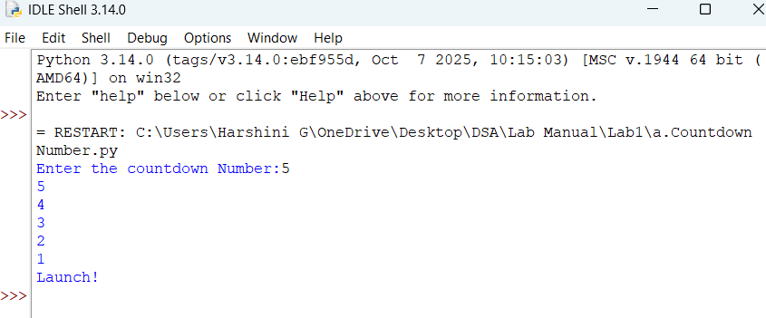
OUTPUT(-VE):
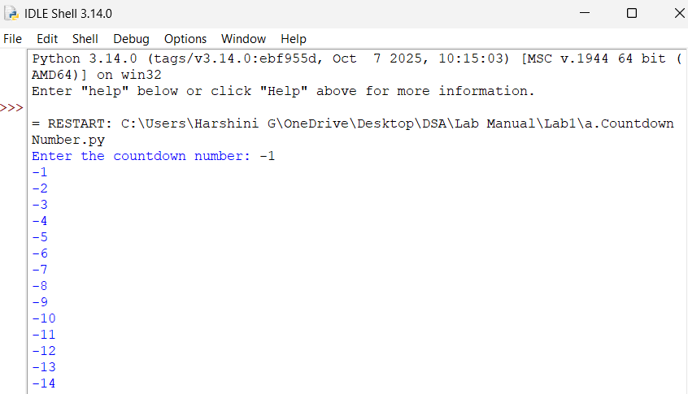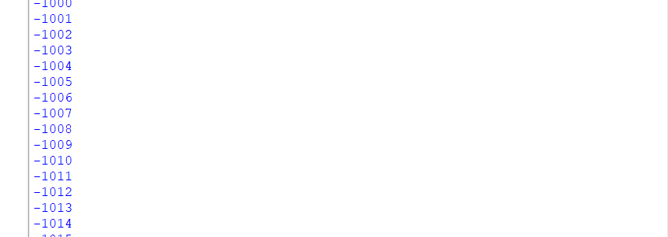
1b) AIM: Banks calculate the growth of an investment using compound interest. The formula requires calculating powers, which can be implemented recursively, write a recursive program to calculate p^n (power) where:
p=principal growth factor, n=no. of years.
CODE:
def power(p, n):
if n == 0:
return 1
else:
return p * power(p, n - 1)

p = float(input("Enter the principal growth factor: "))
n = int(input("Enter the number of years: "))
result = power(p, n)
print("Power =", result)
OUTPUT(+VE):
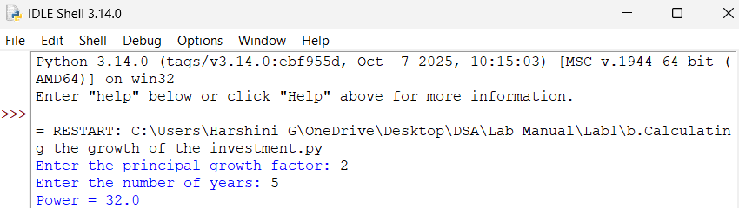
OUTPUT(-VE):
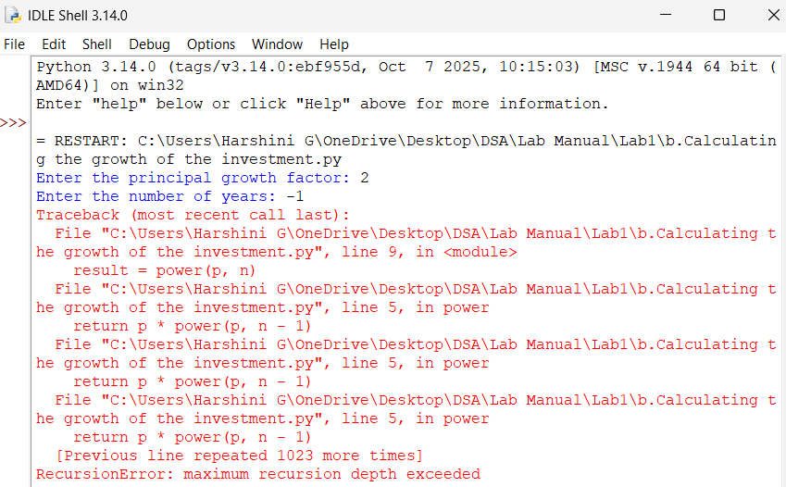
1c) AIM: An HR department stores employee IDs in a list. Develop a recursive program to search for a given employee ID. Write a recursive function search for an employee ID in a list.
CODE:
def search(ids, key, index):
if index == len(ids):
return -1
if ids[index] == key:
return index
return search(ids, key, index + 1)
ids = [101, 205, 310, 415, 520]
key = int(input("Enter employee ID to search: "))
result = search(ids, key, 0)
if result != -1:
print("Employee ID found at position:", result)
else:
print("Value is not found")
OUTPUT(+VE):
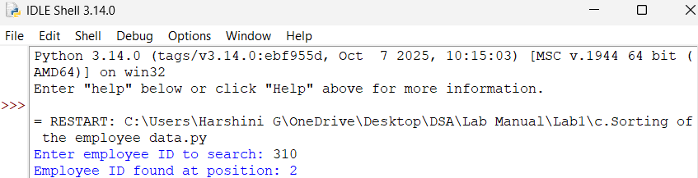
OUTPUT(-VE):
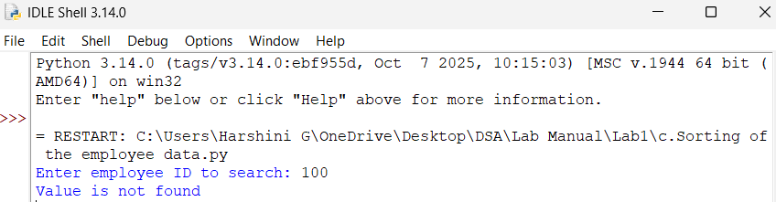
1d) AIM: In a logistics company, the no of possible ways to arrange n different parcels are calculated using the factorial formula(n!). Develop a recursive program to calculate the factorial of a given number.
CODE:
def factorial(n):
if n == 0 or n == 1:
return 1
return n * factorial(n - 1)
n = int(input("Enter number of parcels: "))
if n < 0:
print(f"The factorial of {n} is not defined")
else:
print("Number of possible arrangements of parcels:", factorial(n))
OUTPUT(+VE):
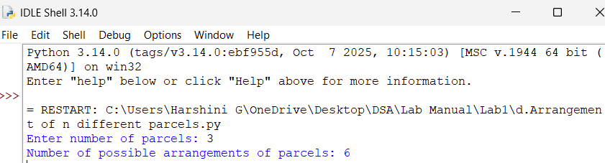
OUTPUT(-VE):
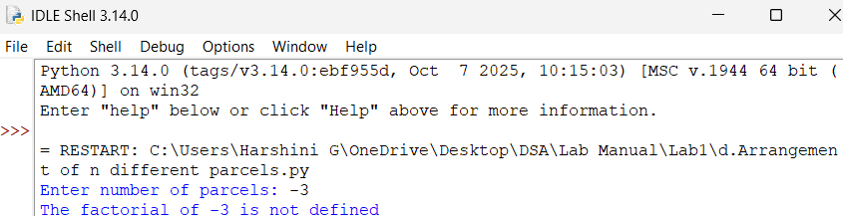
1e) AIM: Write a recursive python program to print the 1st ‘n’ terms of Fibonacci series.
CODE:
def fibonacci(n):
if n <= 1:
return n
return fibonacci(n - 1) + fibonacci(n - 2)
n = int(input("Enter number: "))
print("Fibonacci Series:")
for i in range(n):
print(fibonacci(i), end=" ")
OUTPUT(+VE):
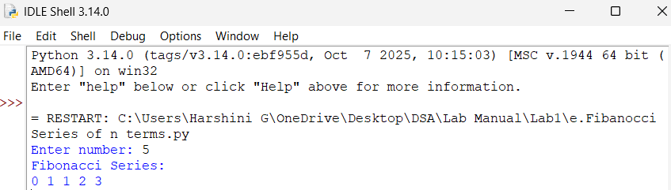
OUTPUT(-VE):
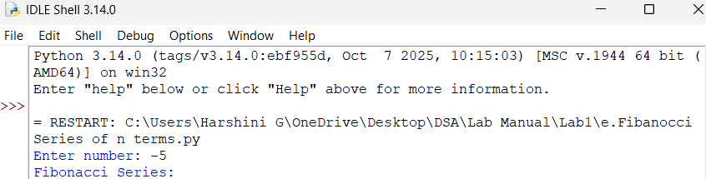
WEEK-2
2a) AIM: Write a python program to implement linear search.
CODE:
arr = [10, 20, 30, 40, 50]
key = int(input("Enter the element to search [10-50]: "))
position = -1
for i in range(len(arr)):
if arr[i] == key:
position = i
break
if position != -1:
print("Element found at position:", position + 1)
else:
print("Element not found")
OUTPUT(+VE):
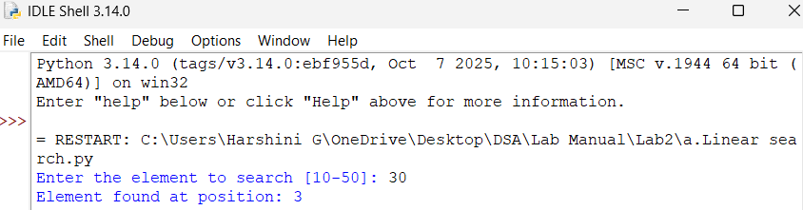
OUTPUT(-VE):
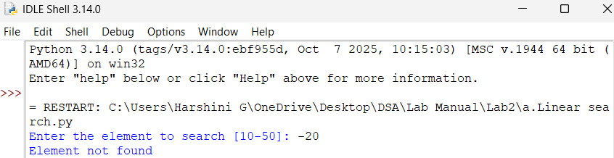
2b)
i) AIM: Write a python program to implement binary search with sorted array as an input.
CODE:
n = int(input("Enter the number of elements: "))
arr = []
print("Enter elements in sorted order:")
for i in range(n):
arr.append(int(input("Enter element: ")))
key = int(input("Enter element to search: "))
low = 0
high = n - 1
while low <= high:
mid = (low + high) // 2
if arr[mid] == key:
print("Element found at position:", mid)
break
elif arr[mid] < key:
low = mid + 1
else:
high = mid - 1
else:
print("Element not found")
OUTPUT(+VE):
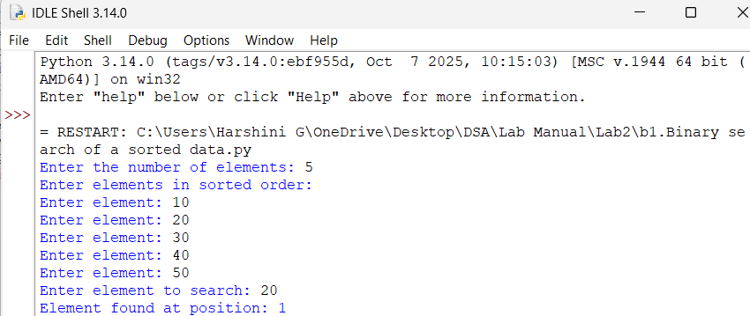
OUTPUT(-VE):
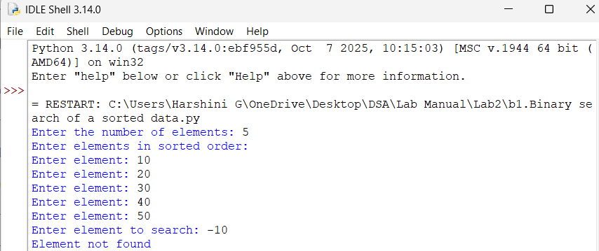
ii) AIM: Write a python program to implement binary search without sorted array as an input.
CODE:
n = int(input("Enter the number of elements: "))
arr = []
for i in range(n):
arr.append(int(input("Enter element: ")))
arr.sort()
key = int(input("Enter element to search: "))
low = 0
high = n - 1
while low <= high:
mid = (low + high) // 2
if arr[mid] == key:
print("Element found at position:", mid)
break
elif arr[mid] < key:
low = mid + 1
else:
high = mid - 1
else:
print("Element not found")
OUTPUT(+ VE):
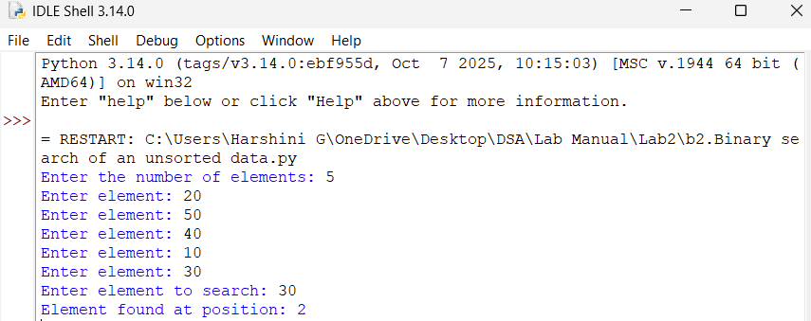
OUTPUT(-VE):
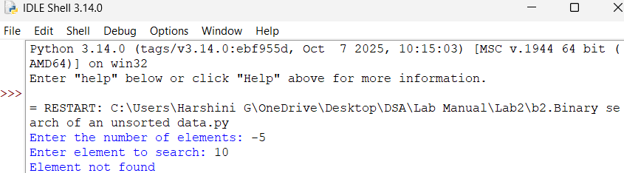
WEEK-3
3a) AIM: Write a python program to implement bubble sort by taking the input.
CODE:
def bubble_sort(arr):
n=len(arr)
for i in range(n-1):
for j in range(n-i-1):
if arr[j]>arr[j+1]:
arr[j],arr[j+1]=arr[j+1],arr[j]
return arr
n=int(input("Enter the number of elements:"))
arr=[]
print("Enter elements: ")
for i in range(n):
arr.append(int(input()))
print("Sorted array:", bubble_sort(arr))
key = int(input("Enter the element to search: "))
if key in arr:
print("Element found")
else:
print("Element not found")
OUTPUT(+VE):
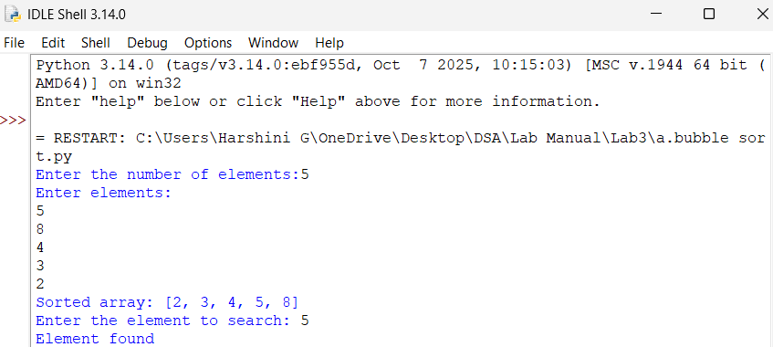
OUTPUT(-VE):
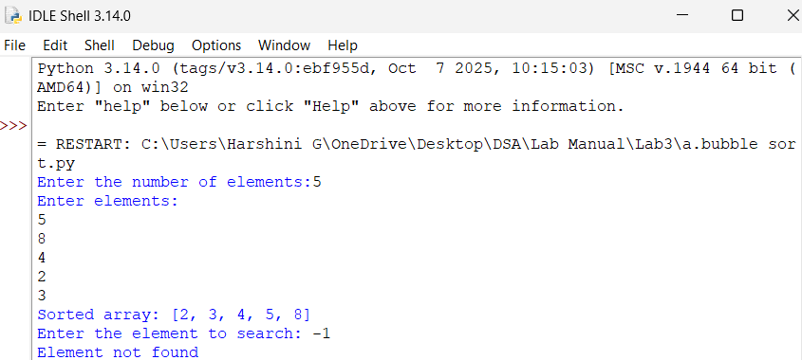
ERROR OBSERVATION:
Invalid syntax: ‘,’ is not entered and there is syntax error.
3b) AIM: Write a python program to implement insertion sort by taking the input.
CODE:
n = int(input("Enter the number of elements: "))
arr = []
for i in range(n):
arr.append(int(input("Enter element: ")))
for i in range(1, n):
key = arr[i]
j = i - 1
while j >= 0 and arr[j] > key:
arr[j + 1] = arr[j]
j = j - 1
arr[j + 1] = key
print("Sorted list:", arr)
OUTPUT(+VE):
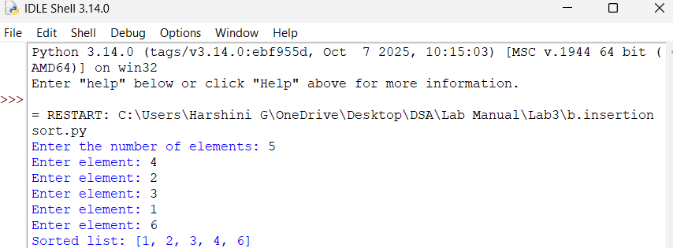
OUTPUT(-VE):
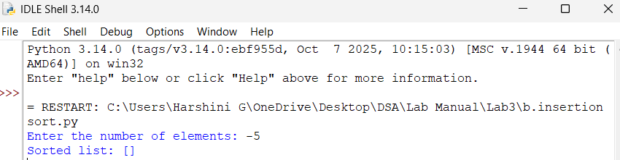
ERROR OBSERVATION:
Invalid syntax: there is an indentation error.
3c) AIM: Write a python program to implement selection sort by taking the input.
CODE:
n = int(input("Enter the number of elements: "))
arr = []
for i in range(n):
arr.append(int(input("Enter element: ")))
for i in range(n - 1):
min_index = i
for j in range(i + 1, n):
if arr[j] < arr[min_index]:
min_index = j
arr[i], arr[min_index] = arr[min_index], arr[i]
print("Sorted list:", arr)
OUTPUT(+VE):
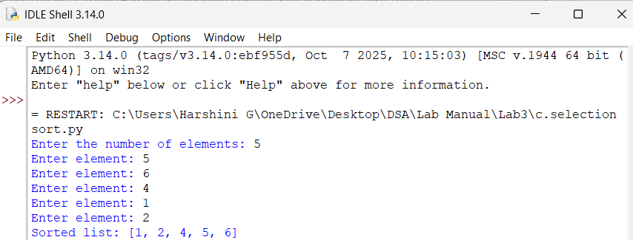
OUTPUT(-VE):
